Interactive Notebook - Fall 2020
Packet 2

Unit 2
Week of October 4th Lesson 1 Grace & Peace

Week of October 11th Lesson 2 To Live Is Christ

Week of October 18th Lesson 3 Worth of Knowing Christ

Week of October 25th Lesson 4 Key Words to Know

Week of October 4th Lesson 1 Grace & Peace

Bible:
- Can you find the words grace and peace in your bible in Philippians?
- What does grace mean?
- What does peace mean?

Learn:
- Grace and peace are common words in the bible.
- Grace is the free and undeserved favor of God.
- Peace is calm, free from stress.

Interactive Notebook:
- Color the Grace & Peace fold out (next page)
- Cut out the rectangle following the solid lines.
- Fold the rectangle on the dotted lines to make a fold out.
- Write the meaning of Grace behind the word on the blank side of the fold out.
- Write the meaning of Peace behind the word on the blank side of the fold out.
- Cut out and paste the fold out on the inside of your notebook.

Week of October 4th Lesson 1 Grace & Peace
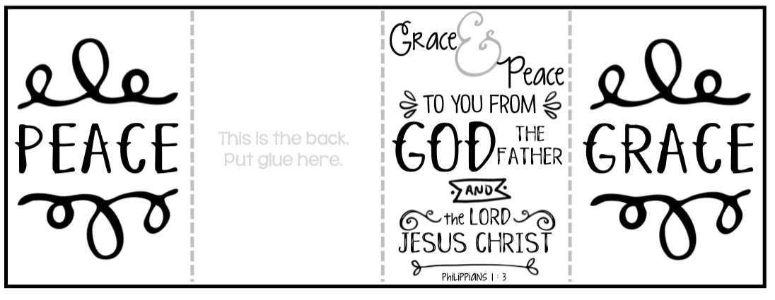

Week of October 11th Lesson 2 To Live Is Christ

Bible:
- Find Philippians 1:21 in your bible.
- Read the verse outloud.
- Discuss what the verse means?

Learn:
- Philippians 1:21 is a well known verse from Philippians.
- “To live is Christ” refers to Paul’s mission to make much of Christ. Paul wants to live a Christ-like life. He wants to be fruitful for Christ with his actions.
- “To die is gain.” Paul knows that he will be with Christ when he dies. This shows us how much Paul values Jesus, everything he will lose when he dies means nothing to him. He gains everything by being united with Chirst.

Interactive Notebook:
- Color the Philippians 1:21 fold out (next page)
- Cut out the rectangle following the solid lines.
- Fold the rectangle on the dotted lines to make a fold out (Philippians 1:21 should be on top)
- On the next available page in your notebook, glue and paste the fold out.
- Try to memorize the verse, unfolding it as you go.

Week of October 11th Lesson 2 To Live Is Christ

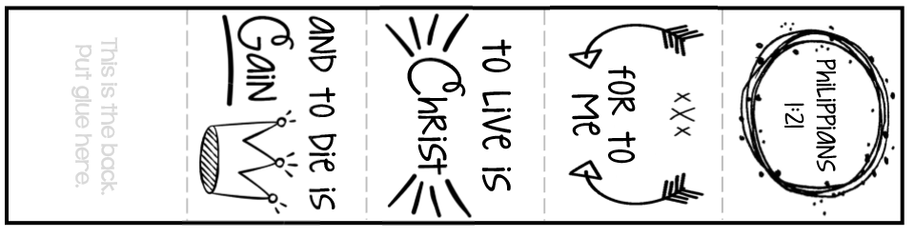

Week of October 18th Lesson 3 Worth of Knowing Christ

Bible:
- Find Philippians 3:8 in your bible.
- Read the verse outloud.
- Discuss what the verse means?

Learn:
- Paul endured many bad things because he was a follower of Christ.
- Paul explains in this verse that nothing that he has lost for being a Christian is really important, none of it matters.
- He tell us that knowing Christ Jesus as his Lord is all that matters.
- He calls everything in comparison to knowing Christ “garbage.”

Interactive Notebook:
- Color the two cut outs (next page).
- Cut out the rectangle and square following the solid lines.
- Fold the rectangle on the dotted lines to make a match book, top folds over.
- Paste the square with verse 3:8 on the inside of the match book.
- On the next available page in your notebook, glue and paste in the match book.

Week of October 18th Lesson 3 Worth of Knowing Christ

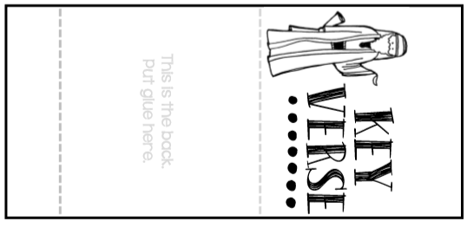

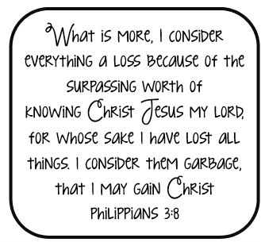

Week of October 25th Lesson 4 Key Words to Know

Research:
- What are some of the key themes or words you have learned so far?
- In your words, what is Paul saying to the Philippians?

Learn:
- Paul was writing to encourage and uplift the church.
- He reminded the church to stay united, and the people to be humble and content.
- Jesus is everything and nothing else matters as much as Jesus.

Interactive Notebook:
- Cut out the Key Words pocket following the solid lines.
- Cut out the Key Words following the solid lines.
- Fold the pocket on the dotted lines and glue down the flaps in your interactive book to make a pocket or holder for the Key Word cards.
- Discuss the key words, talk about what they mean. You can look them up in a dictionary or draw a picture that helps describe or explain the word.
.

Week of October 25th Lesson 4 Key Words to Know

